CASE STUDIES AY 2021-2022

Case Study 3

**Name of Assignment-**

**Roll No.- 33358**

**Batch- N11**

**Contact No.-** 8766925932

**Email Id-** [rapendse2002@gmail.com](mailto:rapendse2002@gmail.com)

**ID card-**



1. What is a private cloud?

Private cloud (also known as an internal cloud or corporate cloud) is a cloud computing environment in which all hardware and software resources are dedicated exclusively to, and accessible only by, a single customer. Private cloud combines many of the benefits of cloud computing—including elasticity, scalability, and ease of service delivery—with the access control, security, and resource customization of on-premises infrastructure.

Private cloud is a single-tenant environment, meaning all resources are accessible to one customer only—this is referred to as isolated access. Private clouds are typically hosted on-premises in the customer's data center. But, private clouds can also be hosted on an independent cloud provider’s infrastructure or built on rented infrastructure housed in an offsite data center.

Many companies choose private cloud over public cloud because private cloud is an easier way (or the only way) to meet their regulatory compliance requirements. Others choose private cloud because their workloads deal with confidential documents, intellectual property, personally identifiable information (PII), medical records, financial data, or other sensitive data.

1. Comparative between private cloud and public cloud.

|  |  |
| --- | --- |
| Public Cloud | Private Cloud |
| Cloud Computing infrastructure shared to the public by service provider over the internet. It supports multiple customers i.e, enterprises. | Cloud Computing infrastructure shared to private organizations by service providers over the internet. It supports one enterprise. |

|  |  |
| --- | --- |
| Multi-Tenancy i.e, Data of many enterprises are stored in a shared environment but are isolated. Data is shared as per rule, permission and security. | Single Tenancy i.e, Data of single enterprise is stored. |
| Cloud service provider provides all the possible services and hardware as the user-base is world. Different people and organizations may need different services and hardware.  Services provided must be versatile. | Specific hardware and hardware as per need of enterprise are available in private cloud. |
| It is hosted at a Service Provider site. | It is hosted at a Service Provider site or enterprise. |
| It is connected to the public internet. | It only supports connectivity over the private network. |
| Scalability is very high, and reliability is moderate. | Scalability is limited, and reliability is very high. |
| Cloud service providers manage clouds and customers use them. | Managed and used by a single enterprise. |
| It is cheaper than private cloud. | It is costlier than public cloud. |
| Security matters and depend on the service provider. | It gives a high class of security. |
| Performance is low to medium. | Performance is high. |
| It has shared servers. | It has dedicated servers. |
| Example : Amazon web service (AWS) and Google AppEngine etc. | Example : Microsoft KVM, HP, Red Hat & VMWare etc. |

1. Draw necessary diagrams for both private cloud and public cloud.

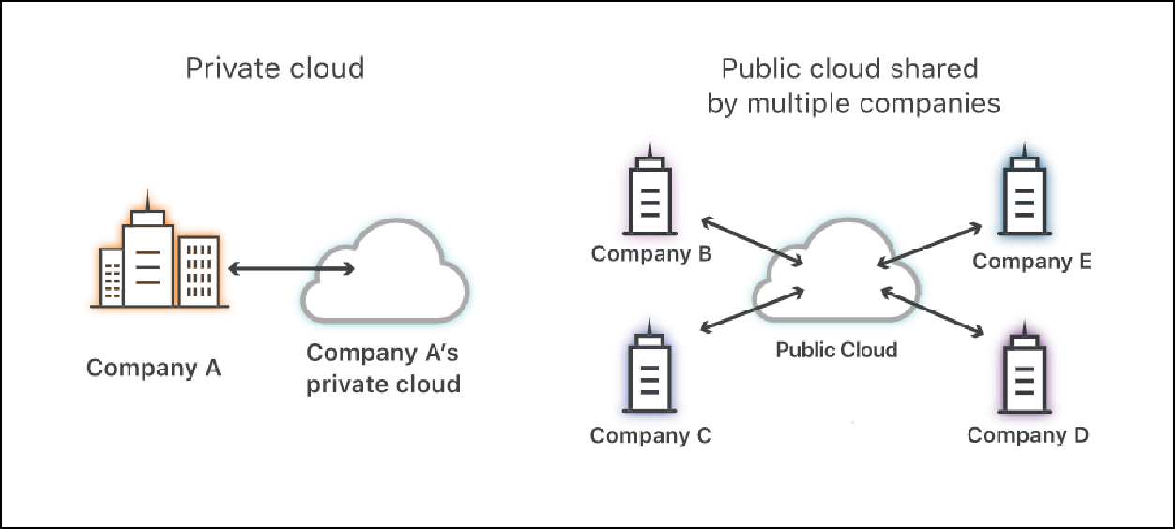

1. List the Tools for building private cloud.

The tools are:

* + Cloudify
  + ManageIQ
  + OpenStack
  + Apache Cloudstack
  + Eucalyptus
  + FOSS-Cloud
  + Docker
  + Salt Stack
  + Cloud Foundry

1. Explain any Tools for building private cloud with necessary diagram and explanation

# OpenStack:

OpenStack is an IaaS private or public cloud. It can control a large pool of compute, storage, and network resources either within a data center as a private cloud or outside as a public cloud.

However, many of the OpenStack public cloud deployments have fallen behind in terms of the features and functions offered by the big three public cloud providers.

OpenStack works and plays well with popular enterprise and open-source technologies, making it ideal for heterogeneous infrastructures, both within OpenStack and on external public clouds.

One potential advantage of going with OpenStack is its ecosystem, which is a thriving marketplace. Moreover, OpenStack has more interest than CloudStack, from a larger population of developers that support the base code.

The approach to cloud management is exactly the same as that in CloudStack. It's all about running a multi-cloud deployment from the OpenStack private cloud using native open-source cloud management tools.

Again, this is an approach that more and more enterprises find attractive, considering the influence of public clouds, and the enterprise's need to keep cloud management in an open-source domain, running on its own hardware platforms.

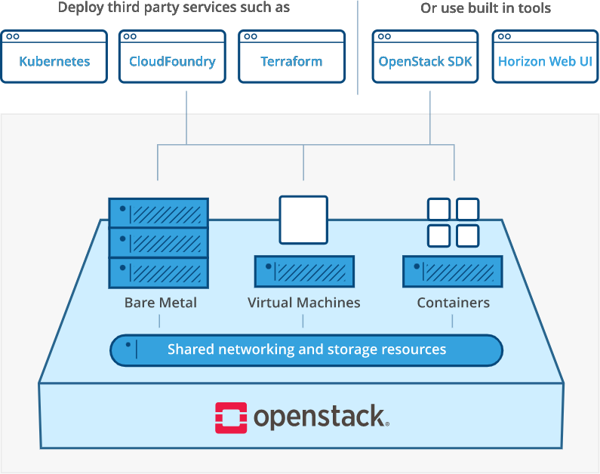

1. **Conclusion**

We learnt and studied about the concepts of private and public cloud and read about the different tools used to build a private cloud.